2016-2017 Activities
S.NO. | NAME OF THE ACTIVITY | DATE
1. | Awareness rally | 03-09-16
2. | Rally on ozone day | 16-9-16
3. | Field trip | 09-11-16
4. | Student seminars | 14-11-16
5. | Quiz | 29-11-16
6. | World Aids Day | 01-12-16
7. | Study Tour | 03-12-16
8. | Work shop on organic farming | 23-12-16
9. | World Science Day Celebrations | 28-02-17

Awareness rally- An awareness rally was conducted by the department on 3-9-2016 along with NCC to use clay idols of Lord Ganesh instead of plaster of paris to prevent environmental pollution.
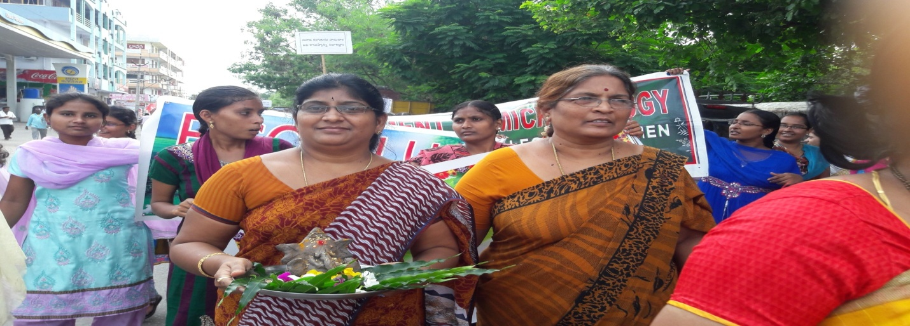
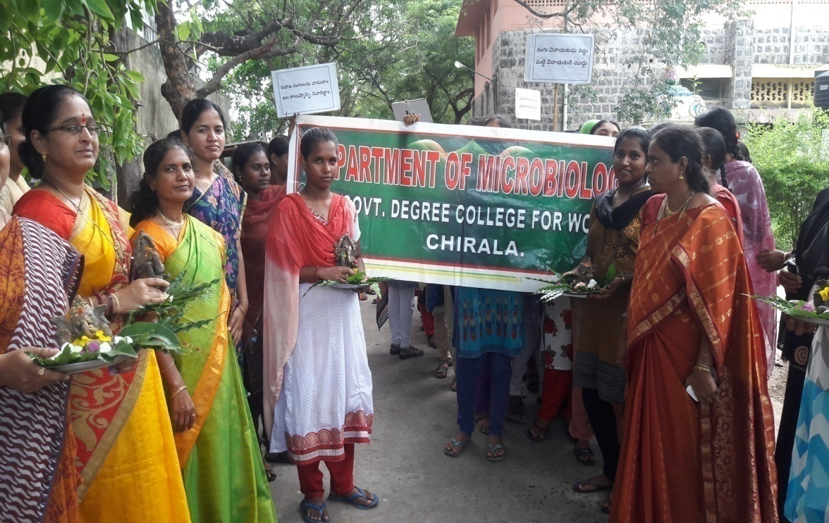
OZONE DAY : International ozone day was observed on 16-9-16. An awareness rally on Ozone day was organized by the department along with other departments to bring awareness among the public about the effects of ozone depletion , preventive measures to be taken, students and the staff planted saplings in the campus garden.
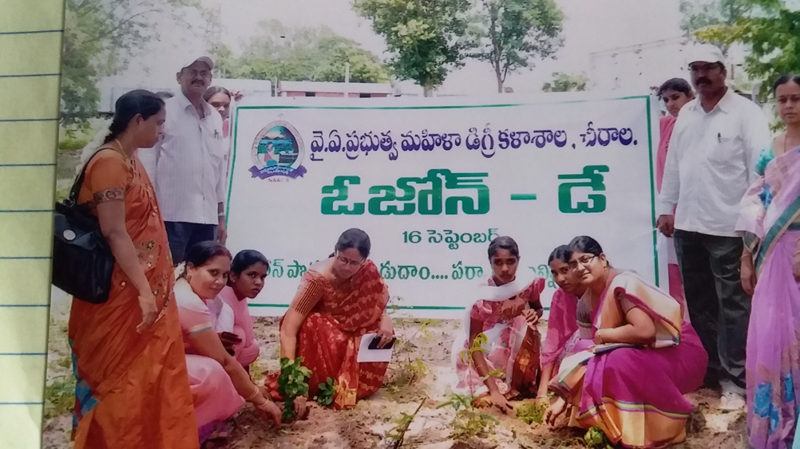
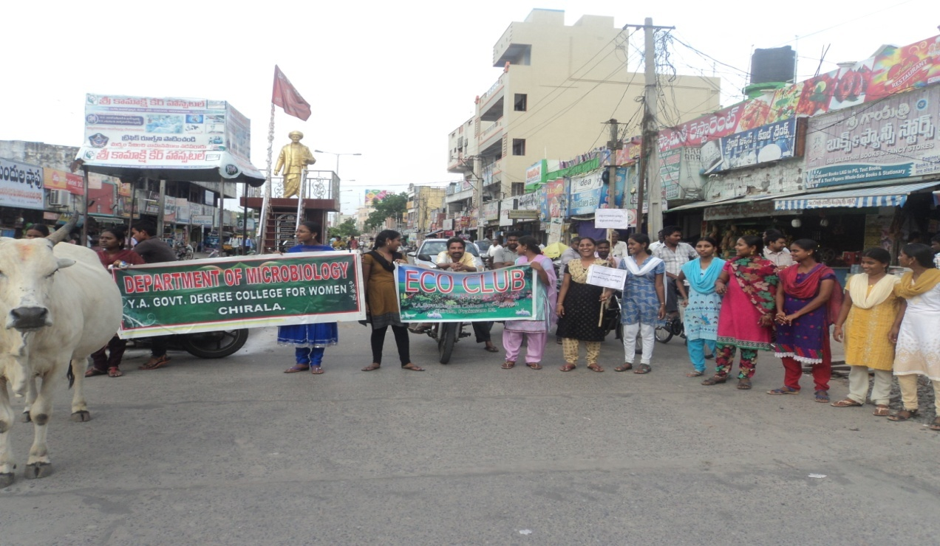
FIELD TRIP: A field visit to ramapuram village was arranged by the department to collect root nodules in the casuarinas fields on 9-11-16. Students have cultured the root nodules for the observation of rhizobium.

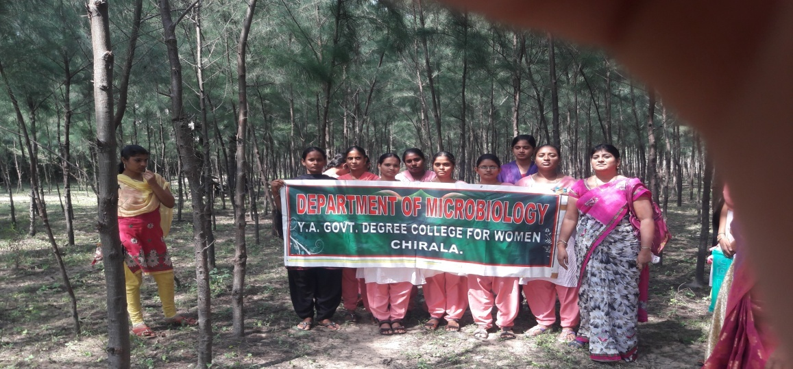

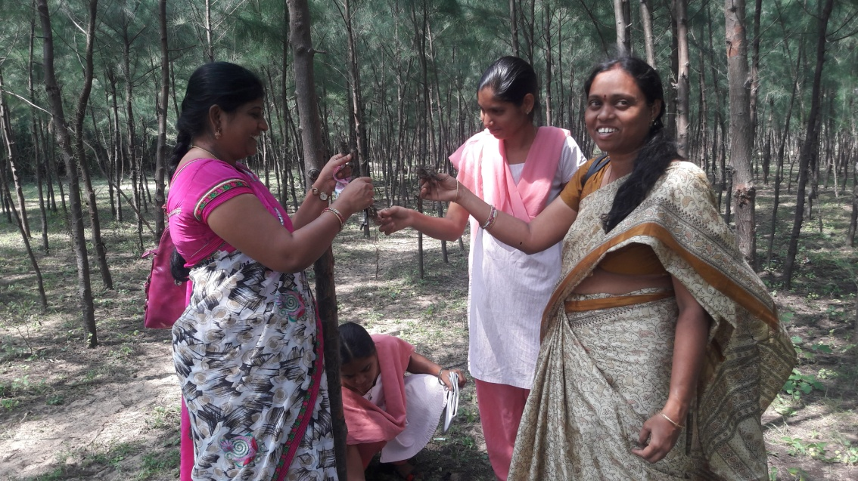

STUDENT SEMINARS: Seminars were given by the II and III MZC students on14-11-16.
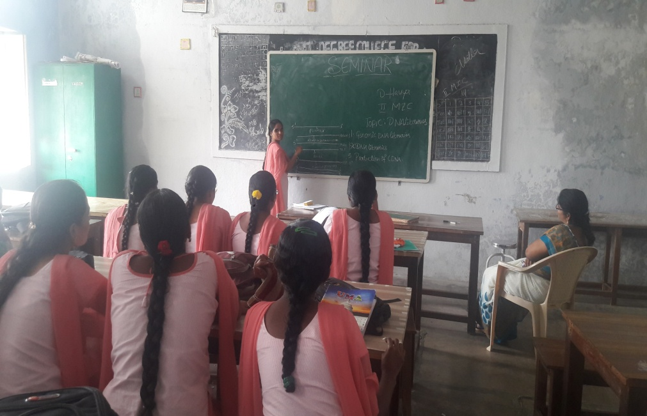

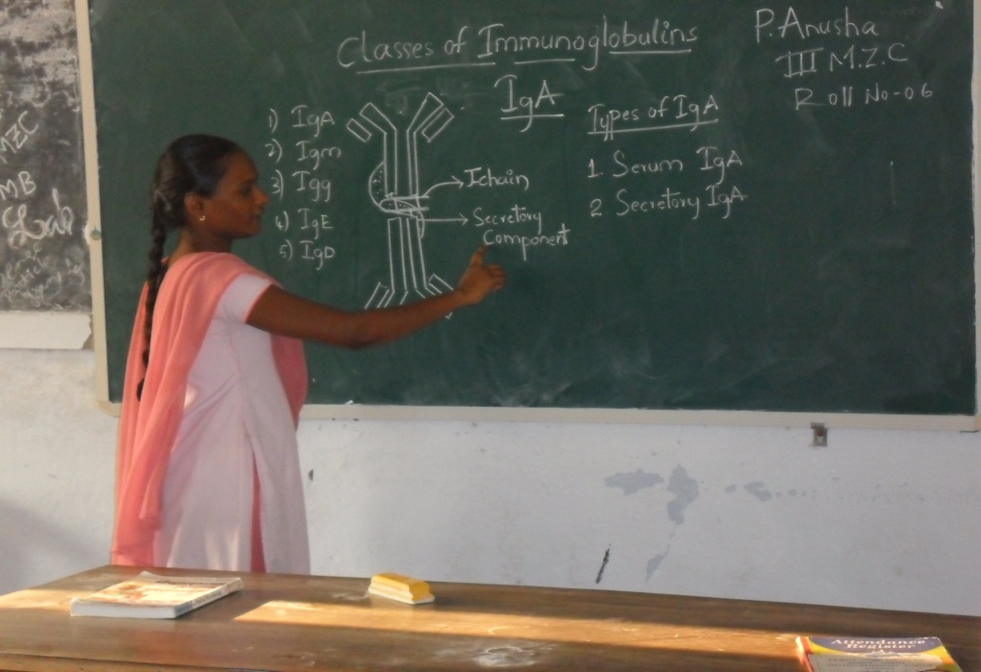

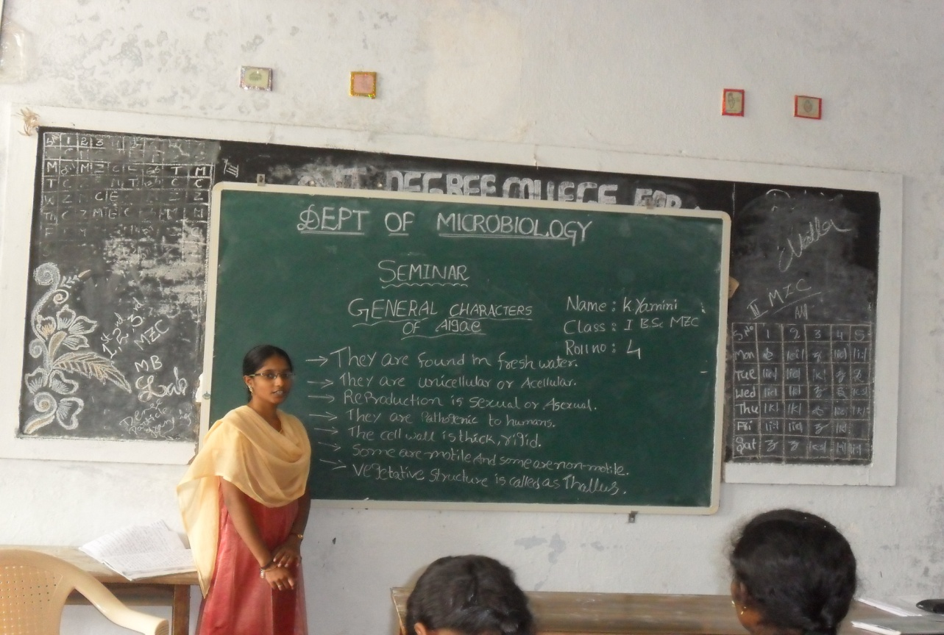

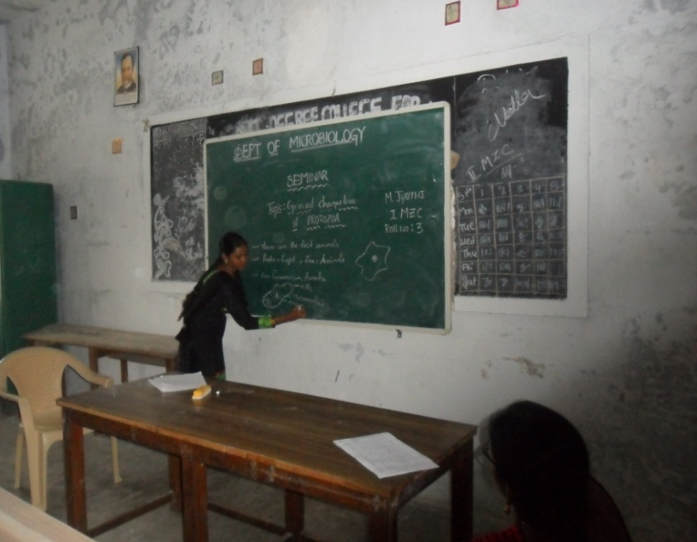

Quiz : A grand quiz competition was held in the college in association with siva sivani institute of management, Hyderabad on 29-11-16. Prizes were awarded to the winners and the winner teams were selected to the state level competition.

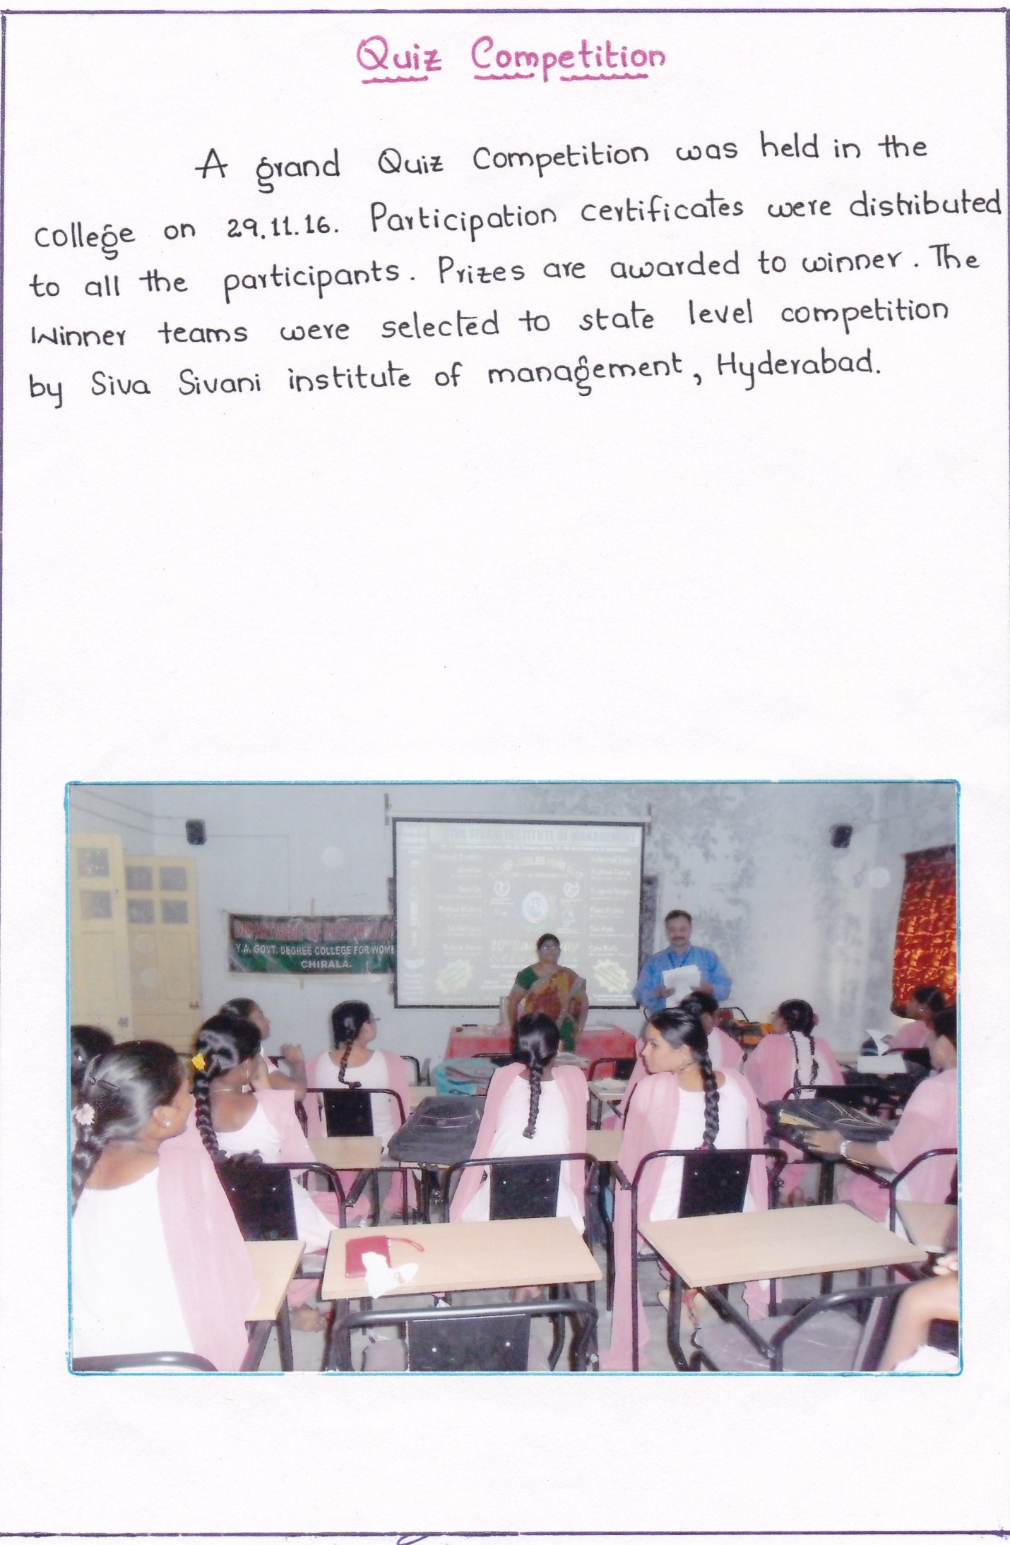

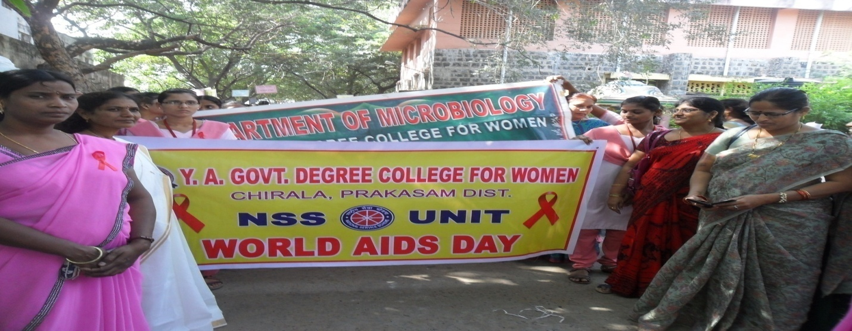
World aids day: world AIDS day was observed on 1-12-16.

Study tour:Department of microbiology has organized a study tour from 3-12-16 to 6-12-16 to Chennai and Bengaluru. Students visited mysore palace, Science museum and also visited chamarajendra zoological gardens.
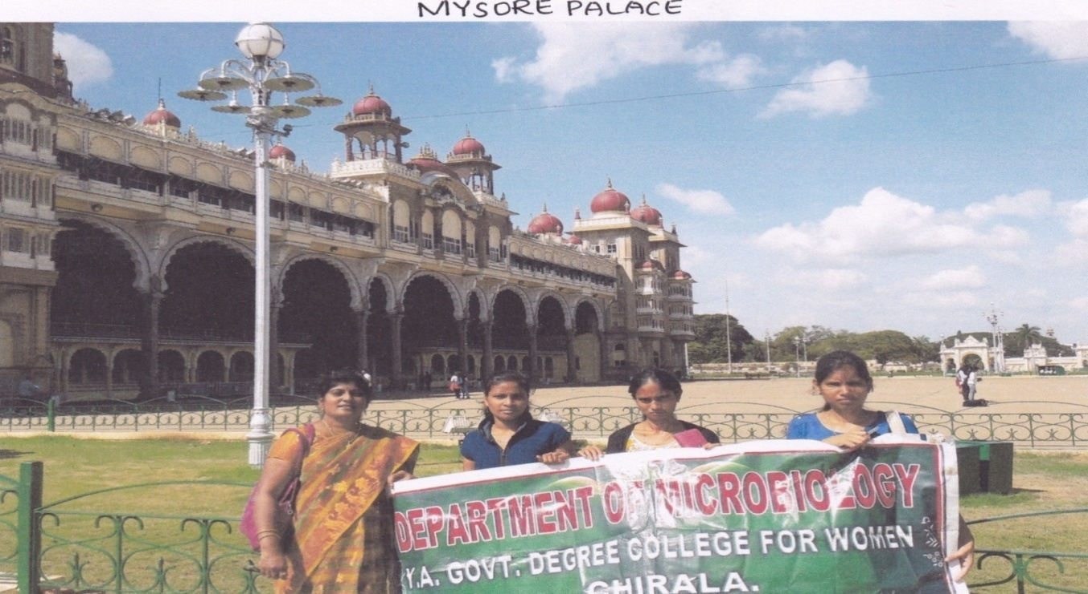

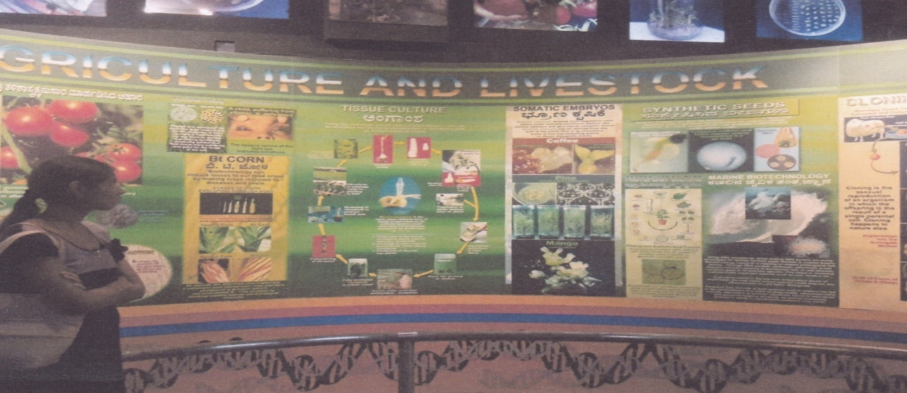

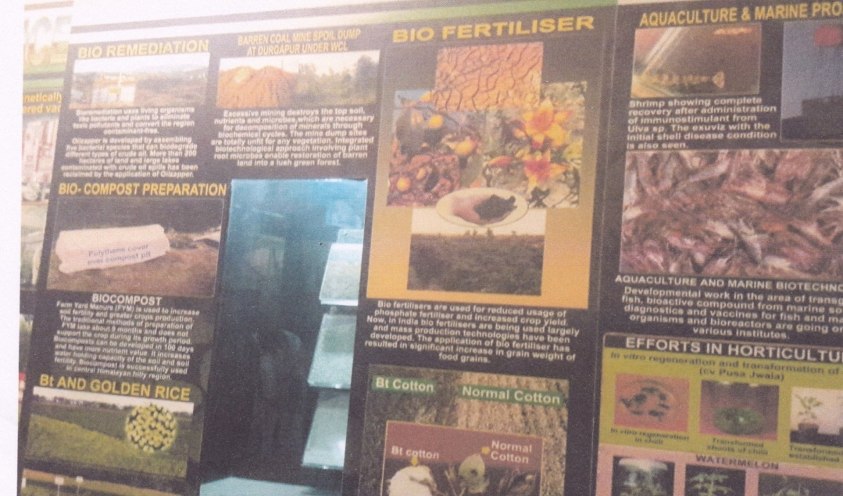

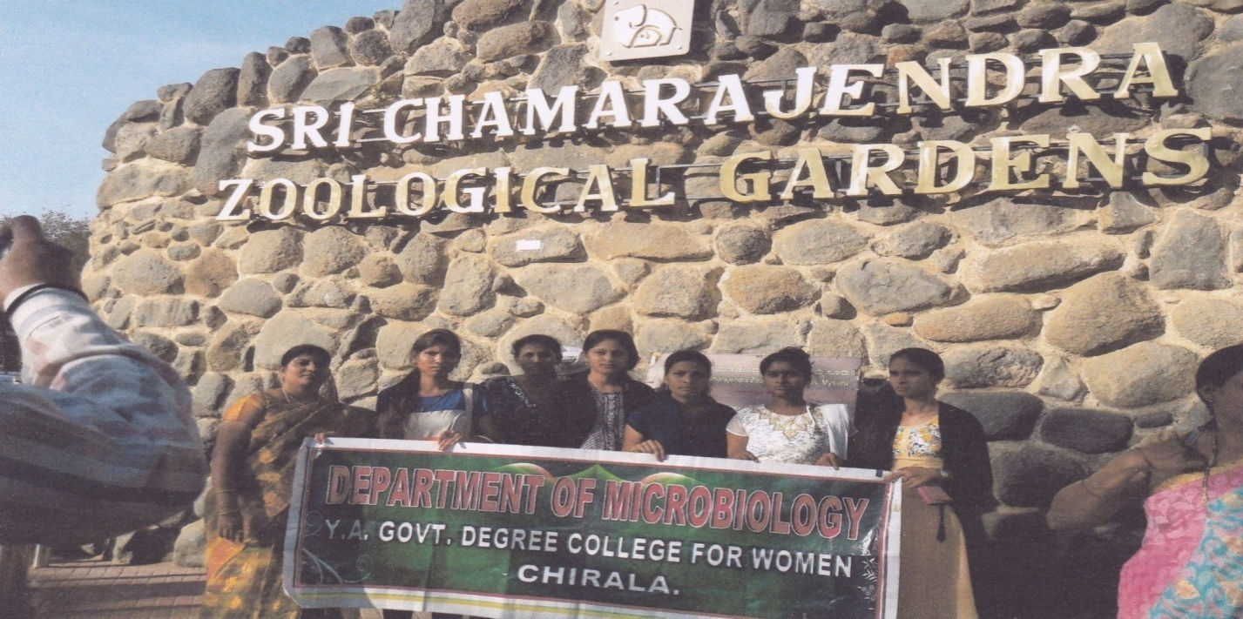
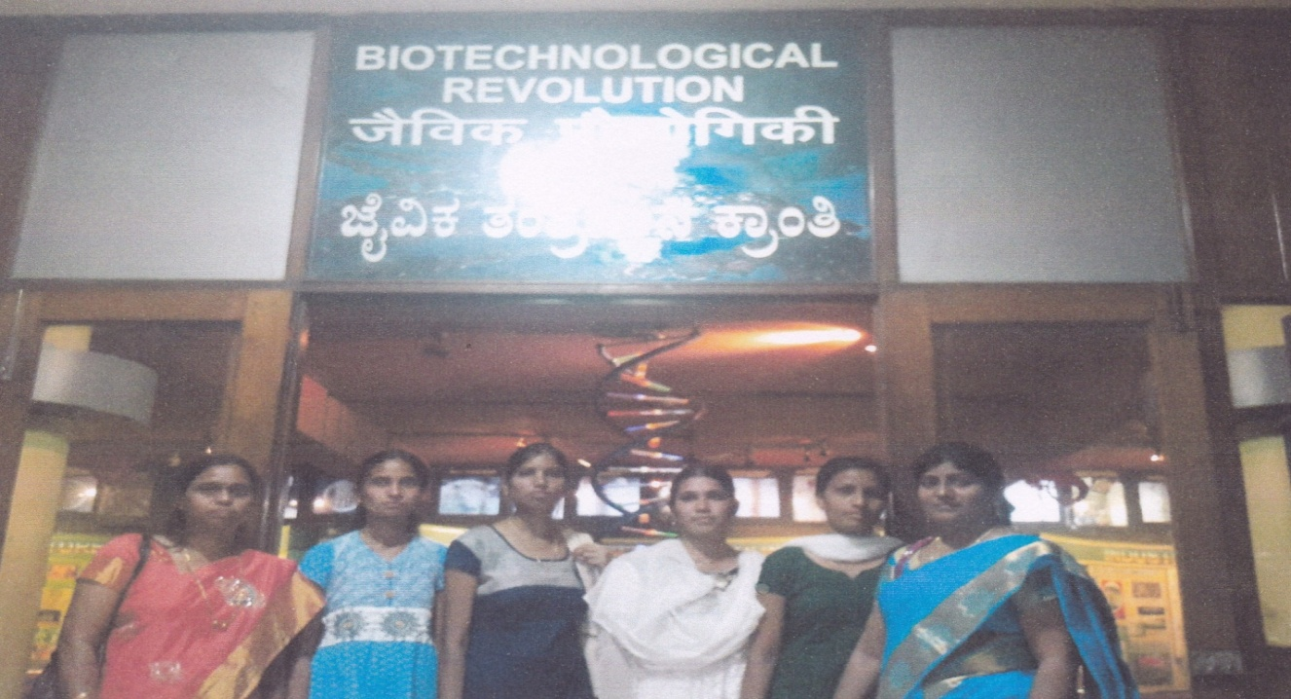

Workshop on organic farming:In collaboration with Botany department a work shop was organized on Organic farming . Sri M.Siva Prasad rao acted as resource person.

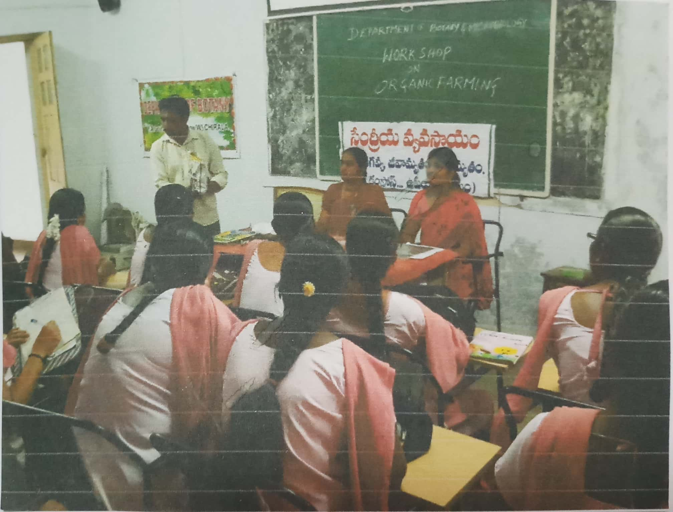

GROUP DISCUSSION: Department of microbiology has conducted a group discussion to the I and II year students.

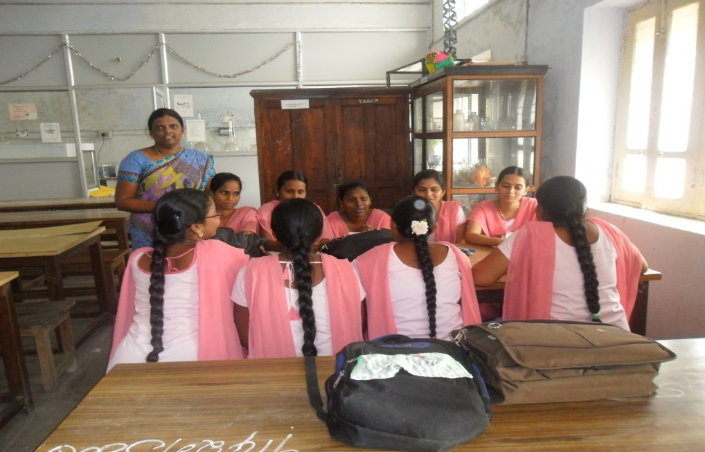

World Science day : On the occasion of World Science day Department of microbiology has organised a two day district level science exhibition in which students displayed models, flow charts and demosntrations on 28-2-2017.

